**PIZZA SALES ANALYSIS(SQL)**

**1.Total Revenue**

select SUM(total_price) AS total_revenue from pizza_sales

*Output*

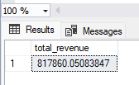

**2. Average order value**

select SUM(total_price) / COUNT(DISTINCT order_id) from pizza_sales

*Output*

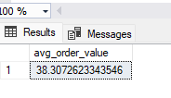

**3. Total pizza sold**

select SUM(quantity) AS Total_pizza_sold from pizza_sales

*Output*

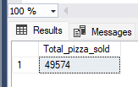

**4. Total orders**

select COUNT(DISTINCT order_id) AS total_orders from pizza_sales

*Output*

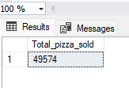

**5. Average pizzas per order**

select cast((cast(SUM(quantity) AS DECIMAL(10,2)) /

cast(COUNT(DISTINCT order_id) AS DECIMAL (10,2))) AS DECIMAL(10,2))

AS avg_pizzas_per_order from pizza_sales

*Output*

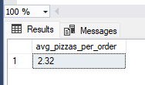

**5.Hourly trend for total orders**

select DATEPART(HOUR, order_time) AS order_hour, SUM(quantity) as total_pizza_sold

from pizza_sales

GROUP BY DATEPART(HOUR, order_time)

ORDER BY DATEPART(HOUR, order_time)

*Output*

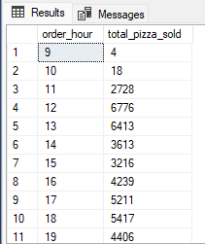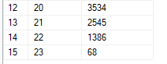

**6.Weekly trend for total orders**

select DATEPART(ISO_WEEK, order_date) AS order_week , YEAR(order_date) AS order_year,

COUNT(DISTINCT order_id) AS total_orders from pizza_sales

GROUP BY DATEPART(ISO_WEEK, order_date), YEAR(order_date)

ORDER BY DATEPART(ISO_WEEK, order_date), YEAR(order_date)

*Output*

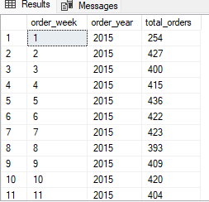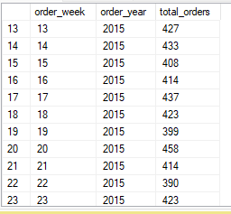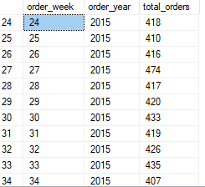

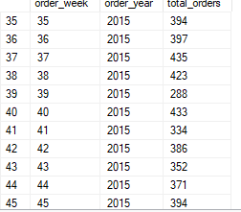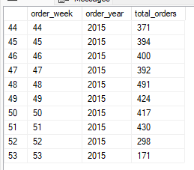

**7. Percentage of sales by pizza category**

select pizza_category,sum(total_price) AS total_sales, sum(total_price)*100 / (select SUM(total_price) from pizza_sales)

AS percentage_of_sales from pizza_sales

GROUP BY pizza_category

*Output*

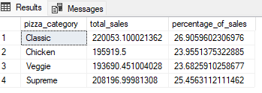

**8. Percentage of sales by pizza size**

select pizza_size,CAST(sum(total_price) AS DECIMAL (10,2)) AS total_sales,CAST(sum(total_price)*100 / (select SUM(total_price) from pizza_sales)

AS DECIMAL (10,2)) AS percentage_of_sales from pizza_sales

GROUP BY pizza_size

ORDER BY percentage_of_sales DESC

*Output*

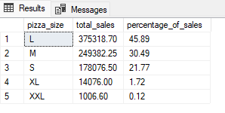

**9.Top 5 bestseller pizzas by revenue**

select TOP 5 pizza_name,SUM(total_price) AS total_revenue from pizza_sales

GROUP BY pizza_name

ORDER BY total_revenue DESC

*Output*

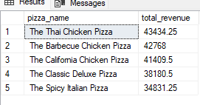

**10. Bottom 5 pizzas by revenue**

select TOP 5 pizza_name,SUM(total_price) AS total_revenue from pizza_sales

GROUP BY pizza_name

ORDER BY total_revenue

*Output*

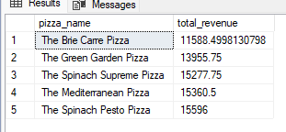

**11.Top 5 bestseller pizzas by quantity**

select TOP 5 pizza_name,SUM(quantity) AS total_quantity from pizza_sales

GROUP BY pizza_name

ORDER BY total_quantity DESC

*Output*

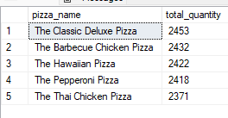

**12.Bottom 5 pizzas by quantity**

select TOP 5 pizza_name,SUM(quantity) AS total_quantity from pizza_sales

GROUP BY pizza_name

ORDER BY total_quantity

*Output*

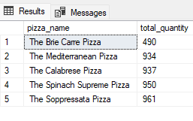

**13. Top 5 pizzas wrt total orders**

select TOP 5 pizza_name,COUNT(DISTINCT order_id) AS total_order from pizza_sales

GROUP BY pizza_name

ORDER BY total_order DESC

*Output*

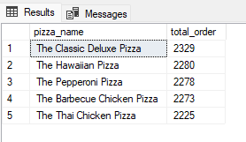

**14.Bottom 5 pizzas wrt total order**

select TOP 5 pizza_name,COUNT(DISTINCT order_id) AS total_order from pizza_sales

GROUP BY pizza_name

ORDER BY total_order

*Output*

